SUMMARY KEY FINDINGS

High-Risk Customer Segment Identified
Customer segmentation analysis was conducted to group customers based on similar service, contract, and billing characteristics. The analysis identified five distinct clusters, each showing different churn behaviour.
Table 1: Churn Behaviour
Cluster | Customer Profile | Churn Rate
Cluster 0 | Long-term contract loyal customers. | 23.14%
Cluster 1 | DSL customers on month-to-month contracts | 24.55%
Cluster 2 | Fibre internet customers on month-to-month contracts | 25.26%
Cluster 3 | Customers with no phone service | 23.14%
Cluster 4 | Senior customers with higher monthly charges | 41.62%

Cluster 4 recorded a churn rate of 41.62%, which is significantly higher than the overall churn rate of 26.5%. The results clearly show that churn is not evenly distributed across the customer base. Instead, it is concentrated within a specific high-risk group characterised by higher billing and customer profile differences.
This confirms that customer characteristics strongly influence churn behaviour and that segmentation provides a structured method for identifying high-risk customer groups. This means customers in this segment were 1.57 times more likely to churn than the average customer.
The results clearly show that churn is not evenly distributed across the customer base. Instead, it is concentrated within a specific high-risk group characterised by higher billing and customer profile differences.
Figure 1: Churn rate by clusters
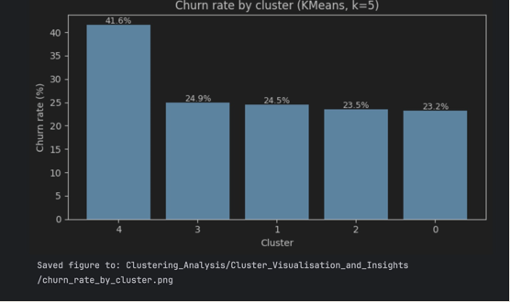

Strong Classification Performance

Figure 2: ROC Curve (test)
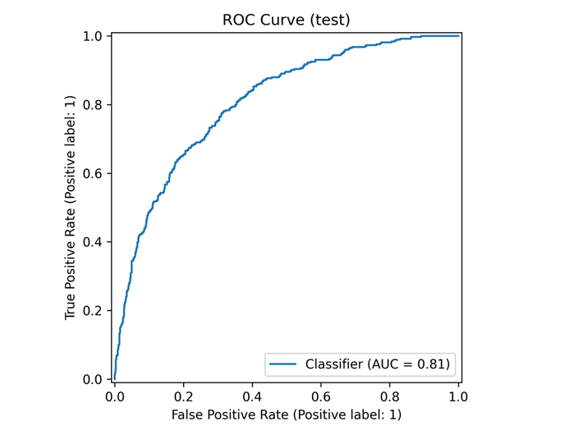
Figure 2: ROC Curve Showing Model Discrimination (AUC = 0.81)
The ANN model achieved a ROC AUC score of 0.81, demonstrating strong ability to distinguish between customers who churned and customers who remained.
An AUC of 0.81 means that when comparing a churned customer and a retained customer, the model correctly assigns a higher churn probability to the churned customer in 81 percent of cases. accurately separate high-risk customers from low-risk customers based on their churn probability.
The ROC curve shows consistently high true positive rates across different probability thresholds, confirming reliable classification performance. This confirms that the model successfully learned behavioural and contractual patterns associated with churn.

Most churners can be identified before cancellation occurs.
After threshold optimisation, the model achieved a recall of approximately 86%. In practical terms, this means that nearly nine out of every ten customers who would churn were flagged as high risk ahead of time. This outcome is particularly important because it enables proactive intervention. Detecting customers early allows retention teams to contact them before dissatisfaction results in cancellation.

Figure 3 – Confusion Matrix
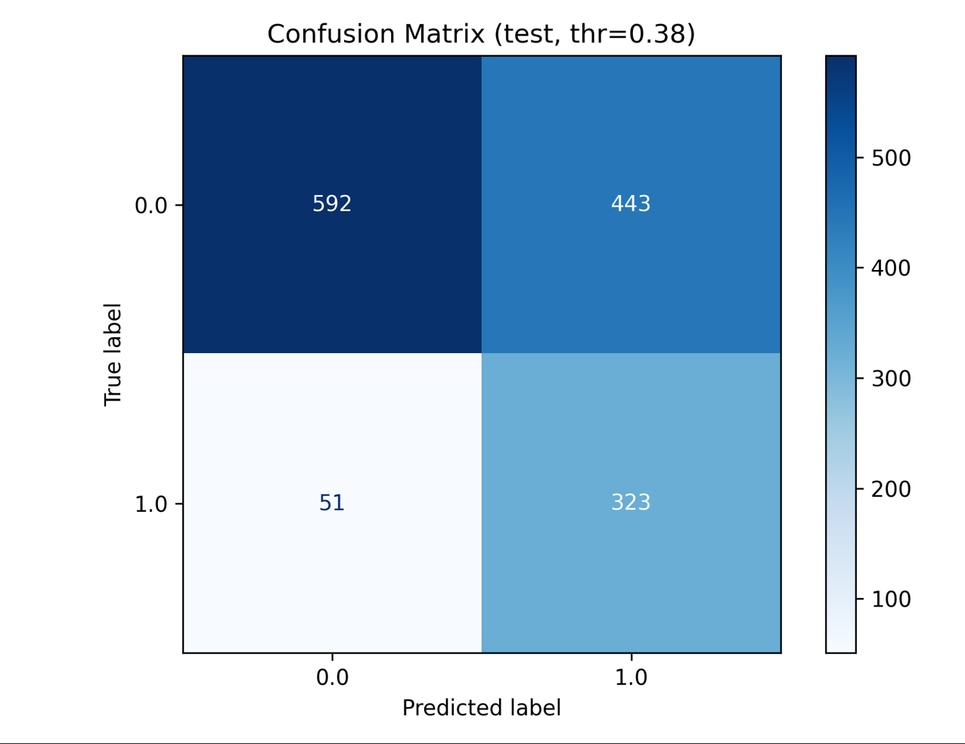
Figure 3: Confusion Matrix Showing Classification Outcomes.
The model was evaluated on 1,409 customers in the test dataset and produced the following results:
- 323 churn customers correctly identified
- 592 retained customers correctly identified
- 51 churn customers missed
- 443 retained customers flagged as churn risk
This resulted in a recall rate of 86.4 percent, meaning the model successfully identified more than 86 out of every 100 customers who churned.
Only 13.6 percent of churn customers were missed, confirming strong detection capability.
This demonstrates that the ANN model can reliably detect customers at risk of churn before they leave.

Reliable Prediction Across Risk Levels
Figure 4 – Precision-Recall Curve (test)
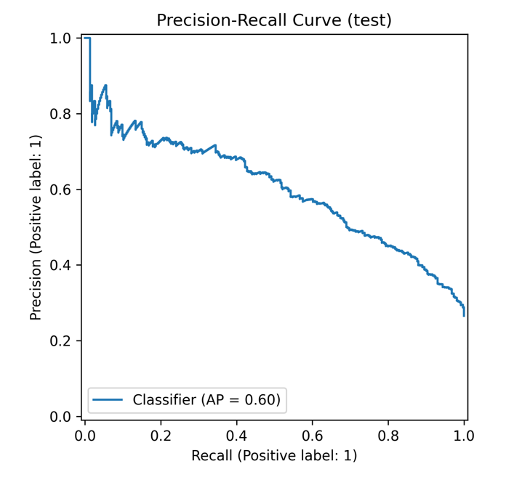
Figure 4: Precision-Recall Curve Showing ANN Model Performance (Average Precision = 0.60)
The model achieved a Precision-Recall AUC score of 0.60, confirming reliable churn prediction performance in an imbalanced dataset where churn represents 26.5% of customers.
The curve shows that the model maintains consistent predictive strength across different probability thresholds. As recall increases, precision gradually decreases, reflecting the expected trade-off between identifying more churn customers and increasing false positives.

Threshold Optimisation Increased Churn Detection
The Artificial Neural Network assigns each customer a churn probability score between 0 and 1, representing the likelihood that the customer will discontinue their service. To convert this probability into a final classification, a threshold is applied. Customers with a predicted churn probability above the threshold are classified as churn risk, while those below the threshold are classified as retained.
Initially, the model used the default threshold of 0.50, meaning only customers with a predicted churn probability greater than 50% were classified as churn risk. At this threshold, the model achieved a churn detection rate (recall) of 75.4%, meaning approximately three out of every four churn customers were correctly identified.
Following threshold optimisation, the classification threshold was lowered to 0.38, allowing customers with a churn probability above 38% to be classified as churn risk. This adjustment increased the churn detection rate to 86.4%.
This improvement enabled the model to correctly identify 48 additional churn customers who would not have been detected using the default threshold. This finding confirms that selecting an appropriate threshold significantly improved the model’s ability to detect churn risk and enhanced its effectiveness in identifying customers likely to leave.

